

American International University-Bangladesh (AIUB)  
**Department of Computer Science  
Faculty of Science &Technology (FST)  
Summer 19_20**

**Section: A  
Group No: 09-Phone Alert System**

A software Engineering project submitted

By

|  |  |  |
| --- | --- | --- |
|  |  |  |
|  |  |  |
|  |  |  |
|  |  |  |
|  |  |  |
|  |  |  |

The project will be Evaluated for the following Course Outcomes

|  |  |
| --- | --- |
| CO3: Choose appropriate software engineering model in a software development  environment | Total Marks |
|  |
| Project Background Analysis (problem, needs, goal, benefits, etc.)[5Marks] |  |
| Appropriate Process Model Selection and Argumentation with Evidence [5Marks] |  |
| Completeness, Spelling, Grammar and Organization of the Answer [5Marks] |  |
|  | |
| CO4: Explain the roles and their responsibilities in the software project  management activities | Total Marks |
|  |
| Content Knowledge (e.g. System Requirements, System Design)[5Marks] |  |
| Project Role identification and Responsibilities descriptions [5Marks] |  |
| Presentation Delivery and Defense[5Marks] |  |

**Text Format:**

* Style: Times New Roman
* Size: 12
* Line spacing: 1

1. **PROBLEM DOMAIN**
   1. **Background to the Problem**

Phone Alert System is an application which allows mobile phone users to manage

information about their incoming calls and messages. When we leave a mobile somewhere and

we want all the information of messages sent to a particular email id, this application will send

them according to the mentioned time slots. Here the users are allowed to specify the duration

when the phone might be left unattended and they will receive the information accordingly. In

this application we can receive incoming messages and missed calls for every 5 min through

email. It will also automatically change the mode of the phone to Silent/Ring/Vibrate according

to the message sent to the mobile. Whenever we want to change the mode of a mobile phone

automatically we can do it by just sending a message from any phone.

Here we can integrate the mobile with email system so that employee or user will

get the notification of email or SMS to their email client which is installed at his or her

workstations.

Generally, we have missed calls and messages on the phone when it is left unattended.

We also keep searching for our phone whenever we leave it somewhere. The idea of changing its

mode automatically just my sending a message and the idea of mailing the necessary information

to one's email actually intrigued me. Android operating system, being open source, provides very

good support to developers and helps programmers to develop many extended applications. This

application will be extremely useful as it is a requirement for many people to get the information

about their incoming messages or calls when it is left unattended.

**1.2 Solution to the Problem**

The main purpose of this app is to manage call, message of the client’s phone. This app will send notification of incoming phone call and messages along with content. So first the app will require app permission from the users of the phone and message apps of the smartphone. Then it will ask for the specific email id where the client want to get the mail. Then user can set time period of getting email. The app will simply collect the information from the phone and messages app and save it to its app data. It will send those informations via email to user’s email id at the given time period. The user can turn off the service any time by pressing off button. This app will be based on IOS/android platform. As we all know android is an open source project, it has a great support for the developers. And it is a very lightweight app. So it doesn’t require high end smartphone either. This app will be available in Google Play store and IOS App Store. Both platform will have free and paid version of the app. Free app contain minor adds and the paid app will be free of adds. So this app will be appropriate for business perspective and will be appropriate for future maintenance update.

There are some apps that give notification to email like Youtube, Facebook, Uber etc. But as the phone and message apps are the default built in apps of a smartphone it has no feature like phone alert system. So the concept of this app is not brand new but the targeted purpose is unique.

1. **SOLUTION DESCRIPTION**
   1. **System Features**

**Functional Requirement:**

* **Software Login**
  1. Software shall allow users to login with username & password.
  2. If the login successful Home page will be displayed.
  3. If login not successful, a random verification code will be generated & immediately sent to the user’s email address by the system to further login.
  4. If incase the login attempt exceed 3times, the system automatically block that particular user account login for the next 15 minutes.
* **Priority Level:** High
* **Precondition:** User have valid id & password
* **Feature list:**

**Missed Call Collector:**

Gathering missed call information via back ground services are done here. All missed calls are collected by the content provider and are sent to the database. All the numbers in the call logs are gathered by using broad casting.

**Message Collector**

Gathering message information via back ground services is done here. All the messages are gathered by the content provider and are sent to the database. The phone numbers from which the messages were sent are gathered by using broad casting. (Google ,Tutorials Point, Software Testing).

**Mail Sender**

Sending the missed calls and messages information to desired mail id is done here. Here, we use Gmail domain as our host. All the information which is gathered by using broad cast signals are sent through email by using SMTP protocol.

**Configuration setting**

Here we configure the time settings which we use to set the time at which we need to receive email along with the required phone and message information. All the information about missed calls and messages are sent via email in regular intervals as alerts. The user can select the days on which he or she wants to receive the alerts. Under the time settings the user should select 'from time' and 'to time' to receive the alerts within that time frame.

**Phone Mode Change**

The implementation of changing the mode (Ring/Silent/Vibrate) of the phone when a message is sent is done here. The Phone Alert system is developed using Eclipse Juno IDE. Along with Java 1.6, ADT plug-in for Eclipse is installed for Android Development Environment. User interface is developed using XML and the business logic is developed using Java.

* **Minimum System Requirement**

**Operating System:** Android, IOS

**RAM:** 512 MB

**Disk Space:** 50 MB or higher

As this app is pretty lightweight application its minimum system requirement is pretty low.

**2.2 UML Diagrams**

**Use-case Diagram**

**Activity Diagram**

**Class Diagram**

**ER Diagram**

1. **SOFTWARE DEVELOPMENTLIFE CYCLE**
   1. **Process Model**

The Project is based on feature. So among many SDLC method we think FDD (Feature Driven Development) method will be best for this current project. There are some important features in this software project. So if we carry this project through FDD it will be best.

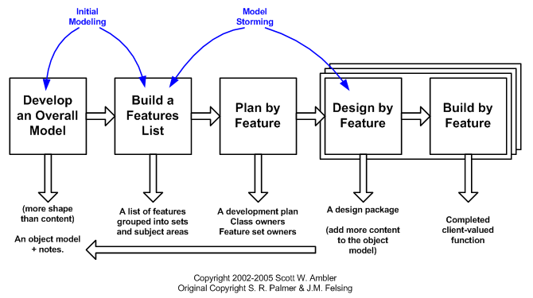

There are several steps in FDD method. First we have to develop the overall method. Then feature list are created. Then plan is made based on features. Then design and the core are made based on feature. As our project has several features, So among some agile method FDD is the best method for this kind of the project. Each feature takes maximum 1-5 days.

So unlike other agile method should be faster and more efficient. For these reason we choose this SDLC.

1. **UI and UX Design**

**UI Design for the project is given below:**

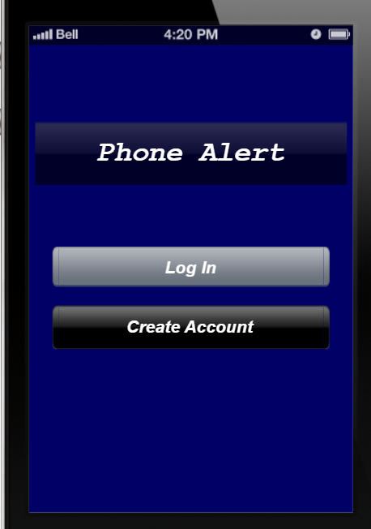

**Figure 4.1: Start**

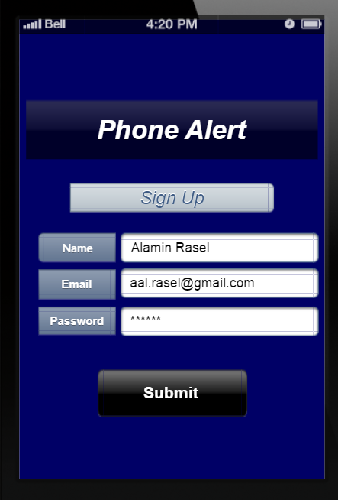

**Figure 4.2: Sign Up**

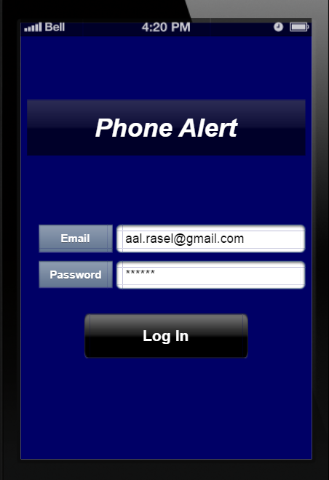

**Figure 4.3: Log In**

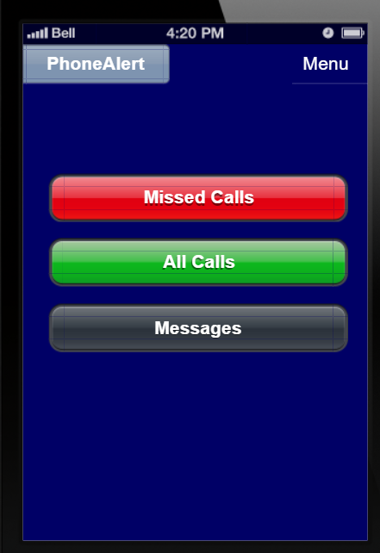

**Figure 4.4: Home**

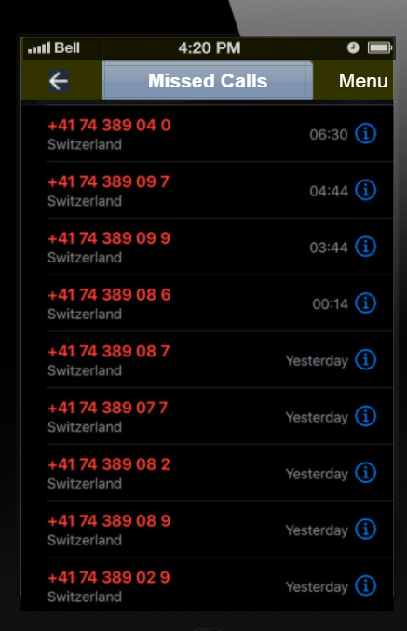

**Figure 4.5: Misseds Call**

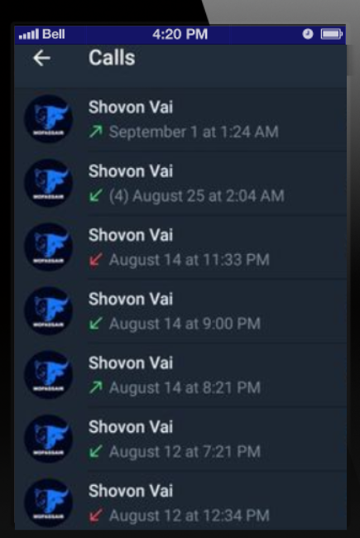

**Figure 4.6: All Calls**

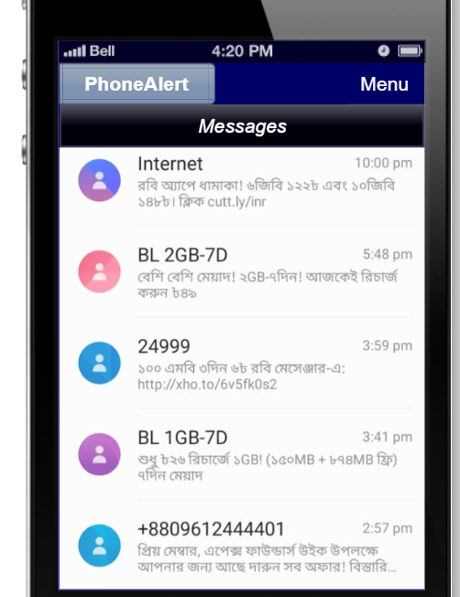

**Figure4.7: Messages**

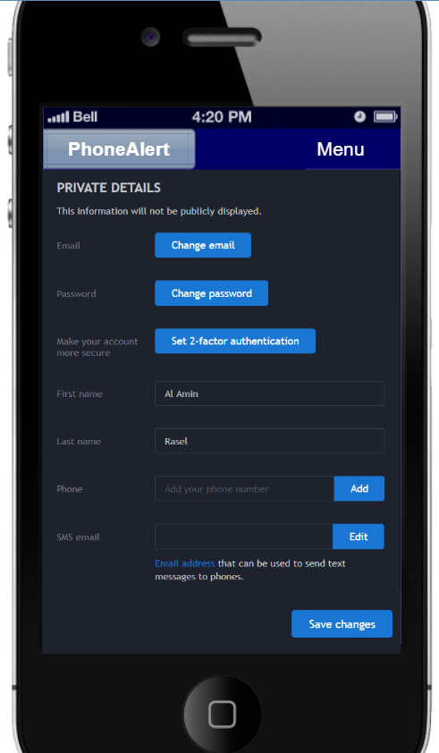

**Figure 4.8: Menu**

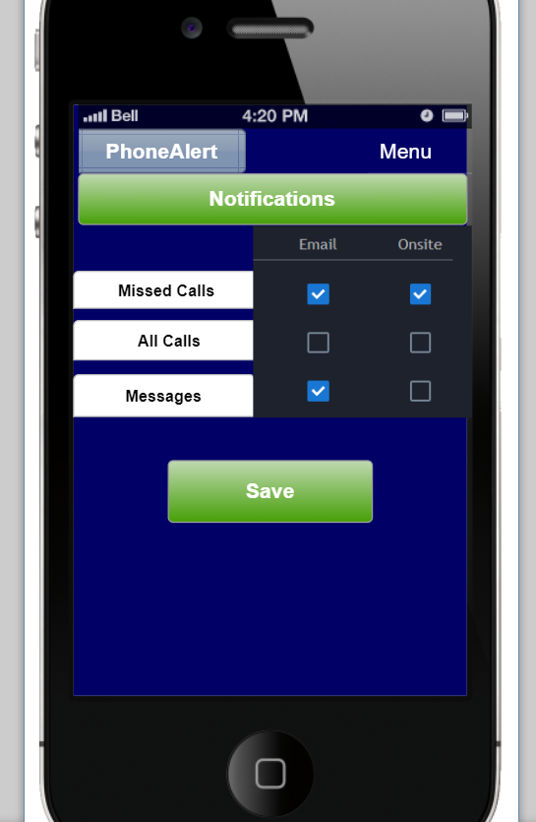

**Figure4.9: Notifications and Settings**

1. **Project Test:**

Software testing is a process of evaluating the system to check whether it satisfies all the requirements. Testing is done for one or more components and/or properties of the software system. The below are the objectives of the testing.

·All the requirements that are mentioned in the design document are to be met

•The application built should respond correctly and in an expected manner for all the inputs given to the system

•All the system functions are to be performed within the stipulated and acceptable time

•The developed application should be sufficiently usable

**Text Case Template and Example**

|  |  |  |  |  |  |
| --- | --- | --- | --- | --- | --- |
| Project Name: Phone Alert System | | | Test Designed by: Jadid Rahman | | |
| Test Case ID: FR_2.1 | | | Test Designed date: 17/09/20 | | |
| Test Priority : High | | | Test Executed by: Al Habib | | |
| Module Name: Login Session | | | Test Execution date: 18/9/20 | | |
| Test Title: verify login with valid username and password | | | | | |
| Description: Software shall allow users to login with username & password. If the login successful Home page will be displayed. | | | | | |
| Precondition : User must have valid username and password | | | | | |
| Test Steps | Test Data | Expected Results | | Actual  Results | Status  (Pass/Fail) |
| 1. Go to the website 2. Enter username/email 3. Enter password 4. Click submit | Username:  Shihab Uddin  Password: 6945 | User should login into the application | | As expected, | Pass |
| Post Condition: User is validated with database and successfully login to account. The account session details are logged in the database. | | | | | |

**Text Case Template and Example**

|  |  |  |  |  |  |
| --- | --- | --- | --- | --- | --- |
| Project Name: Phone Alert System | | | Test Designed by: Jadid Rahman | | |
| Test Case ID: FR_2.1(1) | | | Test Designed date: 17/09/20 | | |
| Test Priority : Medium | | | Test Executed by: Al Habib | | |
| Module Name: Missed Call Collector | | | Test Execution date: 18/9/20 | | |
| Test Title: Missed Call Alert Session | | | | | |
| Description: Gathering miss call information via back ground services is done here. | | | | | |
| Precondition (If any): User must have valid username and password | | | | | |
| Test Steps | Test Data | Expected Results | | Actual  Results | Status  (Pass/Fail) |
| 1. Give Missed Callto the phone | Got a call from Shihan(01665986532) | Send caller information to the email/user name registered | | As expected, | Pass |
|  | | | | | |

**Text Case Template and Example**

|  |  |  |  |  |  |
| --- | --- | --- | --- | --- | --- |
| Project Name: Phone Alert System | | | Test Designed by: Jadid Rahman | | |
| Test Case ID: FR_2.1(2) | | | Test Designed date: 17/09/20 | | |
| Test Priority : Medium | | | Test Executed by: Al Habib | | |
| Module Name: Message Collector | | | Test Execution date: 18/9/20 | | |
| Test Case: Message Alert Session | | | | | |
| Description: Gathering message information via back ground services is done here. | | | | | |
| Precondition (If any): User must have valid username and password | | | | | |
| Test Steps | Test Data | Expected Results | | Actual  Results | Status  (Pass/Fail) |
| 1. Send Message to the Phone | Got a message from Shihan(01665986532 | Send Message information to the email/user name registered | | As expected, | Pass |
|  | | | | | |

**Text Case Template and Example**

|  |  |  |  |  |  |
| --- | --- | --- | --- | --- | --- |
| Project Name: Phone Alert System | | | Test Designed by: Jadid Rahman | | |
| Test Case ID: FR_2.1(3) | | | Test Designed date: 17/09/20 | | |
| Test Priority : Medium | | | Test Executed by: Al Habib | | |
| Module Name: Mail Sender | | | Test Execution date: 18/9/20 | | |
| Test Case: Mail Alert Session | | | | | |
| Description: Gathering mail information via back ground services is done here. | | | | | |
| Precondition (If any): User must have valid username and password | | | | | |
| Test Steps | Test Data | Expected Results | | Actual  Results | Status  (Pass/Fail) |
| 1. Send Email to the Phone | Got a mail from Shihan@outlook.com | Send email information to the email/user name registered | | As expected, | Pass |
|  | | | | | |

**Text Case Template and Example**

|  |  |  |  |  |  |
| --- | --- | --- | --- | --- | --- |
| Project Name: Phone Alert System | | | Test Designed by: Jadid Rahman | | |
| Test Case ID: FR_1 | | | Test Designed date: 17/09/20 | | |
| Test Priority : Medium | | | Test Executed by: Al Habib | | |
| Module Name: Configuration Setting | | | Test Execution date: 18/9/20 | | |
| Test Case: Configuration Session | | | | | |
| Description: Configure the time settings which we use to set the time at which we need to receive email along with the required phone and message information. All the information about missed calls and messages are sent via email in regular intervals as alerts. | | | | | |
| Precondition (If any): User must have valid username and password | | | | | |
| Test Steps | Test Data | Expected Results | | Actual  Results | Status  (Pass/Fail) |
| 1.Click on the start app button  2.Give email, time info  3.Click on either one/all the days  4.Click on save button | From Saturday to Friday(12 am to 12 pm0 | Navigate to the screen to give all details  Allows to select timings  All the days that are checked in the checkbox are selected  All the email, Time and days information is stored in database | | As expected, | Pass |
|  | | | | | |  | Allows to select timings |

**Text Case Template and Example**

|  |  |  |  |  |  |
| --- | --- | --- | --- | --- | --- |
| Project Name: Phone Alert System | | | Test Designed by: Jadid Rahman | | |
| Test Case ID: FR_2.1(4) | | | Test Designed date: 17/09/20 | | |
| Test Priority : Medium | | | Test Executed by: Al Habib | | |
| Module Name: Phone Mode Change | | | Test Execution date: 18/9/20 | | |
| Test Case: Phone Mode Session | | | | | |
| Description: The implementation of changing the mode (Ring/Silent/Vibrate) of the phone when a message is sent is done here | | | | | |
| Precondition (If any): User must have valid username and password | | | | | |
| Test Steps | Test Data | Expected Results | | Actual  Results | Status  (Pass/Fail) |
| 1. Store change mode keys as silent, Vibrate, Ring | Stay in(Ring/Vibrate/Silent) | All are stored to database | | As expected, | Pass |
|  | | | | | |

**6. Nonfunctional Requirements:**

**6.1 Protection**

6.1.1 Detection mechanisms

6.1.2 Time and efforts need find key

6.1.3 Ability to resist unauthorized action

6.1.4 Login requirements

Priority level: High

Precondition: Must have an account

Crossover: N/A

**6. 2 Maintainability**

6.2.1 Lifespan

6.2.2 Frequency of Revisions

6.2.3 Resources

Priority level: Medium

**6. 3 Reliability**

**6.3.1. Probability percentage, time;**

6.3.2The number of critical failures, time; and

6.3.3Mean time between failures

Priority level: High

6.4.1 **Usability**

6.4.1 Efficiency of system

6.4.2 Memorability

6.4.3 Show error of user

6.4.4 user Satisfaction

Priority level: Mid

6.5.1 **Integrity**

6.5.1 Fault trapping

6.5.2 Security context impervious to outsider attach

6.5.3 Rights context only the right users can make certain changes

Priority level: Medium